  - 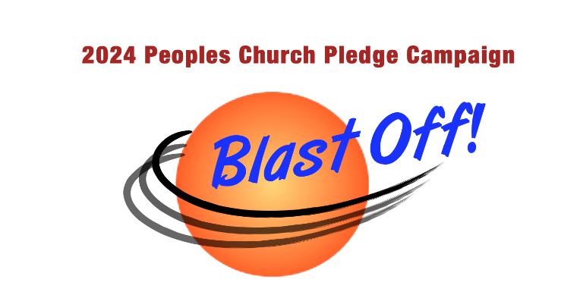
Peoples Church is planning its operating budget for 2024 (pledge payments starting January 2024). Please let us know your intent by marking (X) the items that fit your situation:
_____ Yes! I/we will support PCUU with 2024 pledge or donation!
_____Our name(s) not dollar amount) can be used publicly
_____Please keep our names confidential
_____No, I/we cannot support PCUU with 2024 pledge or donation.
_____I/we want to be/continue to be members and will counsel with the minister about other ways to support the church
_____I/we are not interested in membership or want to end our membership
_____Please take us off the church mailing list
_____Other: ___________________________________________________________________

CONTACT INFORMATION
Name 1 _________________________________ Name 2 _______________________________________
Phone 1 ________________________________ Phone 2 ______________________________________
Email 1 _________________________________ Email 2 _______________________________________
Address________________________________________________________________________________
City, State, ZIP __________________________________________________________________________

OPERATING PLEDGE/DONATION INFORMATION
Last year’s (2023) pledge/donation: $__________ My/our pledge/donation for 2024: $ __________
Method of payment: □ cash □ check □ stock □ auto withdrawal (EFT)*
*If you are not currently making EFT to PCUU, please include a voided check with this form to activate.
Payment amount/frequency (please pick one):
□ $ __________/monthly □$ __________/quarterly □ $ __________/yearly
□ $ __________ /other: ______________________________________________
The pledge treasurer delivers status reports on your pledge/donation as needed.
Everyone gets a prior-year tax report in early February (check here to decline □).
Delivery preference if not declined above (pick one): □ Email □ US mail
____________________________________________________________ ________________________
Signature(s) Date

